Planning Inclusive Communities Research Project

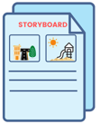
The Storyboard Project - Sharing your Story about Inclusive Communities

Sometimes it is easier to tell a story about what inclusive communities looks like and means to you.

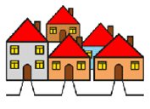
When we say community, we mean where you live. Your home. For example, you live in a suburb in the Clarence City Council area.

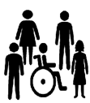
When we say inclusive, we mean you have the same opportunities to do things in your community like everyone else.

To help you tell your story we have some questions for you.

When using this storyboard book, you can:
- Show your answers (drawing, design, photos, collage, etc.)
- Write your answers
- If there is a better way for you to tell us your story – please let us know.

Once you have finished this please send it back to us (follow the instructions on the last page).

We look forward to hearing your story

Important things before you start!
Your private information stays private.
We will keep information about you safe.

No one will know
    - your name
    - age
    - where you live.

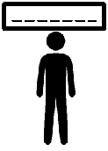
We may use your answers later
But
your name will not be used.
You can ask someone to help you answer these questions.

Remember – You can stop the storyboard at any time.

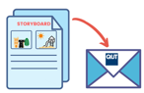
Submitting the storyboard is sign of your consent.

Please answer the following questions before starting
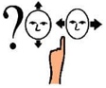
Have you have read the information sheet?
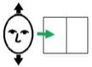
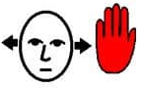
☐Yes – continue reading.
☐No – You can stop now. You can read the information sheet on the Planning Inclusive Communities Storyboard project webpage.
Do you understand what is being asked of you?
☐Yes – continue reading.
☐No -You can stop now. Please ask someone for help or you can contact the researcher Dr Lisa Stafford lisa.stafford@qut.edu.au, Or
Phone: 07 3138 4595
Do you want to do this storyboard activity?
☐Yes – continue reading.
☐No - You can stop now.

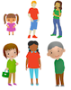
What is your age?
☐9 -12 ☐13 – 17 ☐18 -24 ☐25 – 34
☐35 -64 ☐65+
If you are under the age of 18, you will need to give your parent/ guardian details before starting.

Parent/ Guardian name: Click or tap here to enter text.
Parent/ Guardian best contact details (phone, email, etc):Click or tap here to enter text.
Which council area do you live in?
☐ Clarence City Council.
☐ Gympie Regional Council.
If you do not live in the Clarence City Council or Gympie Regional Council, you can stop now.
Where do you live? (suburb or postcode) Click or tap here to enter text.
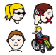
Do you identify as a person with a disability and/or chronic illness?
☐Yes – continue reading.
☐No – please answer the next question.

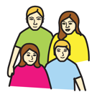
If no, are you are sibling/Family member?
☐Yes – continue reading.
☐No - If no you can stop the storyboard!

Is anyone helping you complete the storyboard?
☐Yes – if yes, who? Click or tap here to enter text.
☐No – continue reading.

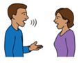
Would you like to be involved in an interview about your storyboard?
☐Yes.
☐No.
If yes, what is your name: Click or tap here to enter text.
and
What is best way to contact you (phone, email, etc):Click or tap here to enter text.
Would you like to be updated on the project?

☐Yes.
☐No.
If yes, what is your email or postal address: Click or tap here to enter text.

This page will be removed from your Storyboard to keep your information safe.

Doing the Storyboard
This next section will ask you questions about your community.
There are 7 questions.
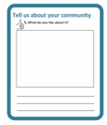
For each question you can:

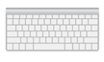
Write your answer
Upload an image
Your images can be drawings, paintings or collages.
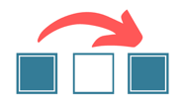
You can skip any question you do not want to answer.

You can now start the Storyboard

Tell us about your community
1. What do you like about it?

Click or tap here to enter text.

2. How does your community include people with disabilities and/or chronic illness?

Click or tap here to enter text.

Tell us about your experience

3. What helps you to be included? For example, what services, activities, spaces, people help you to be included?
You can tell us by writing your answer, inserting an image or choosing the images of things that help you to be included.
Click or tap here to enter text.

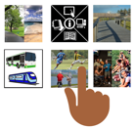
Choose what images below help you to be included. You can choose as many as you want.

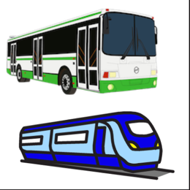
☐ Accessible public transport
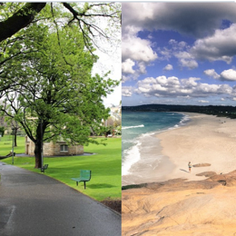
☐ Public Spaces 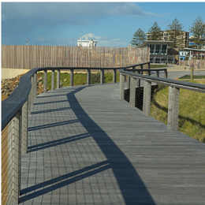
☐ Pathways/ footpaths/ things that help you get around
☐ Accessible Information 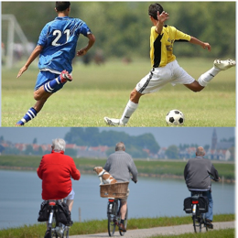
☐ Sporting and recreational activities
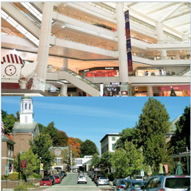
☐ Town centres and shopping centres 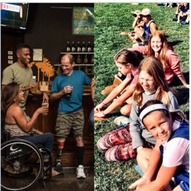
☐ Social Activities
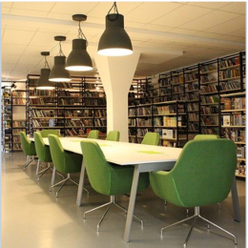
☐ Social Services – libraries and community centre

Tell us about your experience

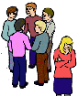
4. What doesn’t help you to be included?

For example, what services, activities, spaces, people do not help you to be included?
You can tell us by writing your answer, inserting an image or choosing the images of things that help you to be included.
Click or tap here to enter text.

Choose what images below do not help you to be included. You can choose as many as you want.

☐ Public transport
☐ Public Spaces
☐ Pathways/ footpaths/ things that help you get around
☐ Information
☐ Sporting and recreational activities
☐ Town centres and shopping centres
☐ Social Activities
☐ Social Services – libraries and community centres

Making your community better
5. Design your ideal inclusive community. (services, activities, spaces, people)
Click or tap here to enter text.

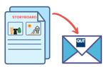
Returning your Storyboard Project
Save a copy of your Storyboard Project.
Once you submit your Storyboard book, we are unable to return it.
Save your word document and email it to us - inclusivecommunities@qut.edu.au

Please contact us if you have any questions:

Email: inclusivecommunities@qut.edu.au
Phone us: 07 3138 4595

