# Interview Participant Information

Easy English Version 2020



Information for an interview on **Planning Inclusive Communities** research.

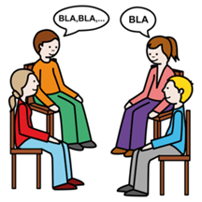

A **group** **interview** is a chat with a researcher.

A researcher learns information to help make things better for people.

The word **chat** will be used in this form.

The research is by Queensland University of Technology. Also called **QUT**.

The researcher is Dr **Lisa** Stafford.

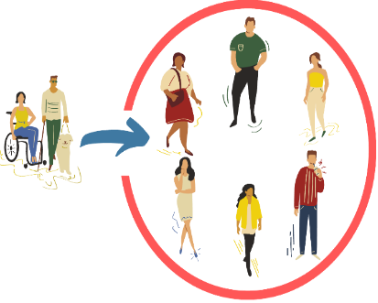The **research** wants to help make communities inclusive for people with disabilities.

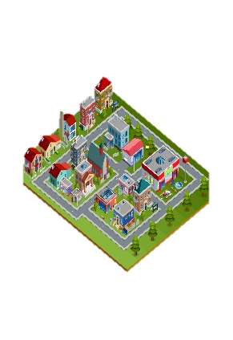

**Community** is the streets and neighbourhood around where you live. Like you live in Clarence City Council near Rosny Park.

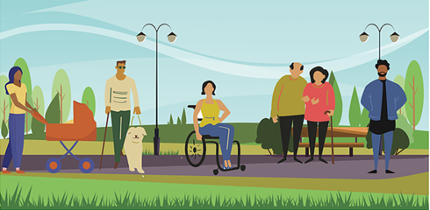

**Inclusive** is having the same choice to do things in your community like everyone else. Like

* Play sports
* Go to shops
* Go to library
* Use the local bus.

**QUT** is working with

Clarence City Council in Tasmania



A group of people at **QUT** check research so it is fair and helpful.

They are called human research ethics committee.



They said our research is okay.

The QUT Research Ethics Approval Number is 1900000898

## What will I be asked?

## In a community chat there will be other people as well as yourself being interviewed at the same time by Lisa the researcher.

We call group interview a community chat.



You will tell us what you think.

The questions are



**?**

1. What makes a community inclusive?



1. What helps make communities inclusive for people with disabilities.



1. What does **not** help make communities inclusive for people with disabilities.



1. Your ideas to make communities better?

## When will we chat?



You need to choose a day and location to go to for the chat.



You do this online by a form called **consent &** **registration form**. <https://qutc.syd1.qualtrics.com/jfe/form/SV_02LRb0Em6t16IPY>

OR

You can also download the form, complete and email it back.

Or Contact the project team via phone 07 3138 5123 or email [inclusivecommunities@qut.edu.au](mailto:inclusivecommunities@qut.edu.au)

and we will send you a copy



You can ask someone to help you. Like a friend or family member.

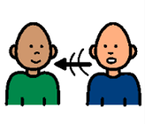

The community chats will be face to face.



But face-to-face may not be a choice with COVID-19.



So it may be a Video call.



We will record what you and others in the group tell us.

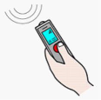

Only your voice will be recorded in a video call.

## Who can have a chat?

You are 9 years and older

*  People **under 18** need parent or guardian okay.

You are

* a person with a disability. This includes **all** disabilities like chronic illness and chronic mental health needs.

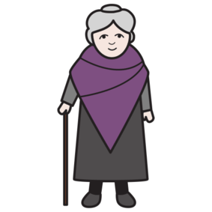

* family member of a person with disability



* Any other person in the community.

You **must** live, work or study in:

Clarence City Council or the Greater Hobart area, Tasmania

## 

## Important information.

Your private information stays private.

We will keep information about you safe.

We may use the answers again in the future.



You can stop the chat at any time.



You can ask someone to help you. Like a friend or family member.

Or

You can ask **Lisa**.

Phone **Lisa**….. on 07 3138 4595



Email **Lisa**……. [lisa.stafford@qut.edu.au](mailto:lisa.stafford@qut.edu.au)

## What will you get from participating?

A report about the information you and others tell us.



We may make a story with this information.



We will give this to people and put it on the [Planning Inclusive Communities website](https://www.planninginclusivecommunities.com/).

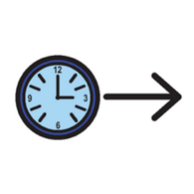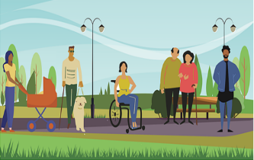Participation in this research project will **not** directly benefit you.

But may help make communities more inclusive in the future.

## Are there risks to me?

You may feel upset telling us about some things. Like what makes it difficult.



You do **not** have to tell us if you don’t want to.

You **choose** what to tell us.

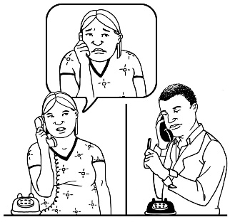

You can talk to a counsellor about things that made you really upset.

Call **Lifeline** on **13 11 14** for 24-hour telephone crisis support

Or

Call **Kids Helpline on 1800 551 800 for people age 5 to 25** years.



## For help to register or any questions contact

Dr **Lisa** Stafford

School of Public Health and Social Work

Queensland University of Technology

Phone….. 07 3138 4595

Or

Email…… [lisa.stafford@qut.edu.au](mailto:lisa.stafford@qut.edu.au)



If you are **not** happy with the research you can make a complaint to the QUT Research Ethics Advisory Team.



Phone….. 07 3138 5123

Or

Email…… [humanethics@qut.edu.au](mailto:humanethics@qut.edu.au)

Keep this information

**Images:** We used images from:

* Mayer-Johnson
* Pictoselector
* Pixabay CC
* Canva
* Pexels, The Change people



The project is funded by the Australian Research Council. DECRA project number DE190101512.

For more information visit [http://www.planninginclusivecommunities.com](http://www.planninginclusivecommunities.com/)