|  |  |
| --- | --- |
|  | **CONSENT FORM FOR QUT RESEARCH PROJECT**  **– Easy Read – Community Chats –** |
| **Making Communities Inclusive:**  **Inclusive community planning for people with disabilities in regional areas.**  **QUT Ethics Approval Number 1900000898** | |



**Have questions?**

Talk to Dr **Lisa** Stafford



Phone  **07 3138 4595**



[**lisa.stafford@qut.edu.au**](mailto:lisa.stafford@qut.edu.au)

**!!! This form is asking if you want to be involved in this research.**



**To do this we need to ask you a few questions.**

| **Please tick the ‘YES’ box if you agree with the information or cross the ‘NO’ box if you don’t agree.** | | **Yes**  **ü** | **No**  **X** |
| --- | --- | --- | --- |
|  | 1. I understand what is being asked of me and understand the information in this form. |  |  |
|  | 2. I have asked any questions I wanted to. |  |  |
|  | 3.I understand that I do not have to do it. |  |  |
|  | 4. I can stop at any time. |  |  |
| 5. If I say no … I will not get into trouble. |  |  |
|  | 6. I understand that my answers will be used in a research project. |  |  |
|  | 7. Your private information stays private. We will keep information about you safe. |  |  |
|  | 8. We may use your answers later but your name will not be used. |  |  |
|  | 9. I agree for the interview to be audio recorded. |  |  |
|  | 10. Do you want to be in this research? |  |  |

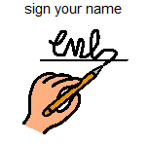

**Name of participant** ........................................................................................

**Signature of participant** ........................................................................................

**Date of signing** ……………….…. / ……..………..…. / ………….…………

**Age** ........................................................................................

**Where you live?** ........................................................................................

**Email** ........................................................................................

**Phone** ........................................................................................

**Name of parent / guardian** ........................................................................................

(Where required: Children under 18 must have a parent/guardian signature.)

**Signature of parent/carer/guardian** ........................................................................................

**More questions next page**

**Choose a location to go to?**



Cambridge Primary School 2 September Thursday 3.15 to 5.15 pm

Risdon Vale Community Centre Saturday 18 September 10.30 am to 12.30

Howrah Community Centre 8 September 5-7 pm

Rosny Library 2 October Saturday 10 am to 12 pm

Clarence Plains - Grace Centre Friday 15 October 10.30 to 12.30 pm

South Arm Community Centre Sunday 31 October 10.30 to 12.30 pm

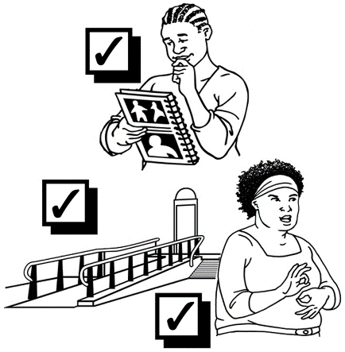**Participation Needs**

**Do you have any specific needs to aid your participation?**

LikeAuslan interpreter, transport.

**Tell us…………………………………………………**



**Tell us any specific food needs you have?**

**Like food allergies, or Coeliac.**

**……………………………………………………….**

**More questions next page**

Returning your consent registration form

Floppy Disk, Save, File, Data, Diskette, StorageSave your word document



Email it to us [inclusivecommunities@qut.edu.au](mailto:inclusivecommunities@qut.edu.au)

Contact us if you have any questions



Phone Lisa…. 07 3138 4595



Email…. **inclusivecommunities@qut.edu.au**