# Photovoice Activity Participant Information

Easy English Version 2020



Information for a research activity on **Planning Inclusive Communities** research.

## About Planning Inclusive Communities Research Project

The research is by Queensland University of Technology. Also called **QUT**.

The **researcher** is Dr **Lisa** Stafford. A researcher learns information to help make things better for people.

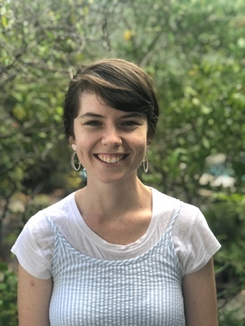

The research **assistant** is **Rosie**.

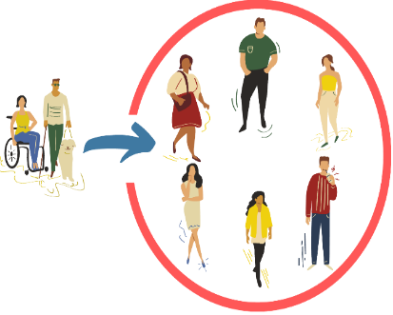

The **research** wants to help make communities inclusive for people with disabilities.

**Community** is the streets around where you live.

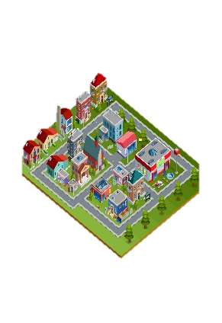

Like you live in Clarence City Council near Rosny Park.

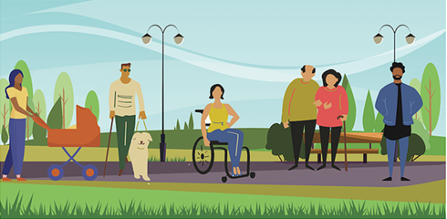

**Inclusive** is having the same choice to do things in your community like everyone else. Like

* Play sports
* Go to shops
* Go to library
* Use the local bus.

**QUT** is working with 2 local councils

Clarence City Council in Tasmania

****and

Gympie Regional Council in Queensland**.**



A group of people at **QUT** check research so it is fair and helpful.

They are called QUT human research ethics committee.



They checked and said our research is okay.

The QUT Research Ethics Approval Number is 1900000898

## The Photovoice Project

A **Photovoice project** uses photos or video to show people what something means.

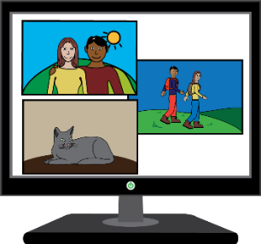

Like what is an inclusive community.

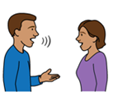You then choose

To talk to a research on your own about your photos or video. We call this one on one interview.

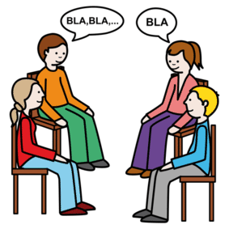Or

You can talk to the researcher in a group about your photos or video.

In a **group interview** there will be other people as well as yourself being interviewed at the same time by Lisa the researcher.

We call group interview a **group chat**.



**?**

## What we want to know?

What makes an inclusive community?



What helps make communities inclusive for people with disabilities.



What does **not** help make communities inclusive for people with disabilities.



Your ideas to make communities better?

## What will I be asked to do?

In this activity you **show** us what inclusive communities means to you by

taking photos

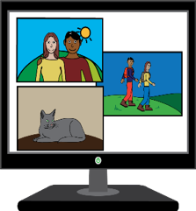Or

make a short video

## You are to do 2 things

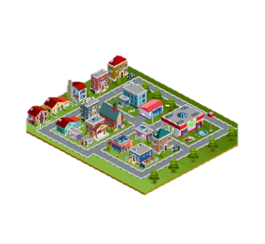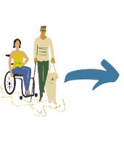

**1.** Take 1 to 6 photos or a short video that shows us what helps make you and people with disabilities and/or chronic illness feel included. Like

* other people
* places like your own town or neighbourhood
* services like library, buses

**2.** Take 1 to 6 photos or a short video of things to fix or change to make community better for people with disabilities. Like

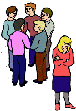

• other people’s attitudes

• places like your town or neighbourhood

• services like library, buses

## What to use to take photos?

You can use your camera.



You can use your phone or tablet to take a picture or video.



You can use video camera to take video. Like a GoPro.

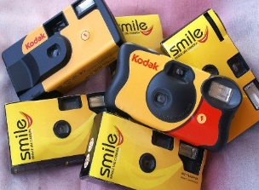

If you do not have a phone or camera contact us.

We can post you a disposal camera



Phone….. 07 3138 4595

Or

Email….. [inclusivecommunities@qut.edu.au](mailto:inclusivecommunities@qut.edu.au)

## List to help take photos



You can ask a family member or friend to help you.

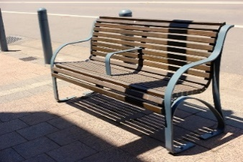

Take photos of whole objects



Do **not** take picture of people’s faces

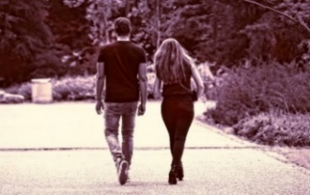

You can take photos of people’s back. Like from behind.

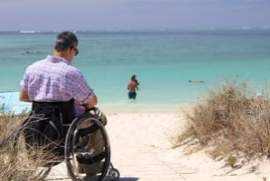

Take photos of person and background.

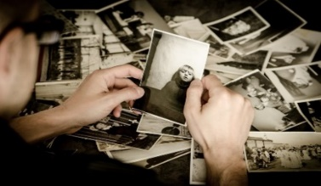

You can take a picture that reminds you of something.



Do **not** take photos straight into the sun.



Take photos with the sun behind you or in the shade.

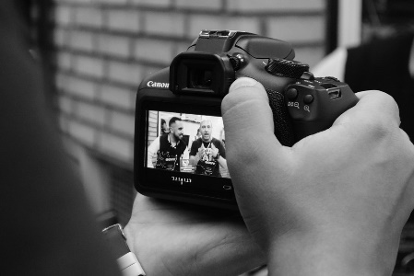

Check your photo. Take another if unsure.



**What do I do after taking my photos**?

Contact **Lisa** when you finish taking photos/video.

Phone … 07 3138 4595



Email …. [inclusivecommunities@qut.edu.au](mailto:inclusivecommunities@qut.edu.au)



We will make a time to chat with you about your photo/videos.

The chat will be one on one or in a group.



You choose.

This chat may occur 1 to 2 months later

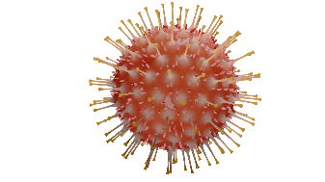

With COVID-19 restrictions we may not be able to offer face-to-face group chat.



We may do the group chat by video call.

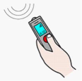

With your okay. We will record what you tell us.

Only your voice will be recorded in a video call.

## Who can have a chat?

You are 9 years and older



* People **under 18** need parent or guardian okay.

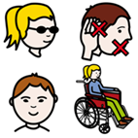You are

* a person with a disability. This includes **all** disabilities like chronic illness and chronic mental health needs.

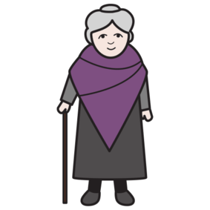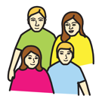

* family member of a person with disability



* other people in the community.

You **must** live, work or study in:

Clarence City Council and the Greater Hobart area Tasmania

Or



Gympie Regional Council Queensland.

## What will you get from participating?

A report about the information you and others tell us.

We may make a story with this information.



We will give this to people and put it on the [Planning Inclusive Communities website](https://www.planninginclusivecommunities.com/).

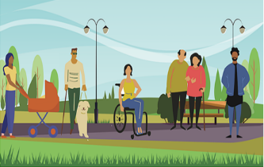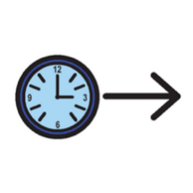Participation in this research project will **not** directly benefit you.

But may help make communities more inclusive in the future.



## Important information

Your private information stays private.

We will keep information about you safe.

We may use the answers again in the future.

Your name will not be used.





You can stop the chat at any time.



You can ask someone to help you. Like a friend or family member.

Or

You can ask **Lisa**.

Phone **Lisa**….. on 07 3138 4595



Email **Lisa**……. [lisa.stafford@qut.edu.au](mailto:lisa.stafford@qut.edu.au)

## Are there risks to you?

Yes. You may get physically hurt if you don’t look when taking photos or filming.



To avoid this:

Take a person with you to help.

Be aware.

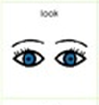

Look where you are going.



Avoid hazards.



Only go to places you feel safe.

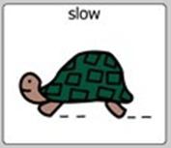

Take your time.

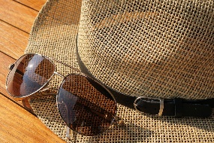

Wear sun protection – hat, sunglasses, sunscreen.



Have some water with you.

Take a phone with you so you can call someone if you need help.

Only do this activity if your feel safe.



There are other ways to participate, like doing the

survey or the storyboard

<https://www.planninginclusivecommunities.com/get-involved>



You may feel upset telling us about some things. Like what makes it difficult.



Sharing things in group where people know what you said can make you worry.



You **choose** what to tell us.

You **do not** have to tell us if you don’t want to.

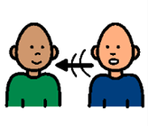

You can **choose** to chat with Lisa on your own.

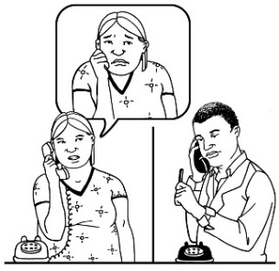

You can talk to a counsellor about things that made you really upset.

Call **Lifeline** on **13 11 14** for 24 hour telephone crisis support

Or

Call **Kids Helpline** on **1800 551 800** for people age 5 to 25 years

## Any questions contact

Dr **Lisa** Stafford

School of Public Health and Social Work

Queensland University of Technology

Phone….. 07 3138 4595

Or

Email…… [lisa.stafford@qut.edu.au](mailto:lisa.stafford@qut.edu.au)



If you are **not** happy with the research you can make a complaint to the QUT Research Ethics Advisory Team.



Phone….. 07 3138 5123

Or

Email…… [humanethics@qut.edu.au](mailto:humanethics@qut.edu.au)

**Images:** We used images from:

* [Freepiks](https://www.freepik.com/)
* PCS_Mayer-Johnson
* Pixabay CC
* Picto-Selecto
* Easy on the I, Your Health Matters
* Change People



The project is funded by the Australian Research Council. DECRA project number DE190101512.

For more information visit [http://www.planninginclusivecommunities.com](http://www.planninginclusivecommunities.com/)

**Keep this information**