# Participant Information for Storyboard Activity



**Research Project: Planning Inclusive Communities**

**QUT Ethics Approval Number 1900000898**

**This page has information about a research study.**



The **research** is about planning communities to be inclusive of people with disabilities.

When we say **community** we mean the area where you live. Your home. For example, you live in a suburb in the Clarence City Council area.

When we say **inclusive** we mean you have the same opportunities to participate in everyday things in your community like everyone else.

The research is by Queensland University of Technology (QUT).

The researcher is Dr **Lisa** Stafford.

QUT is working with two chosen local regional councils

 Clarence City Council Tasmania

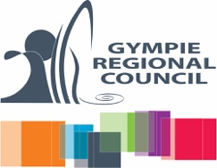Gympie Regional Council Queensland



**EASY READ Version 2020**

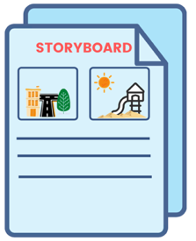This is a storyboard activity

A storyboard helps you tell your story.

It asks a lot of different people the same questions.

We want to know …



**?**

What makes an inclusive community to you?

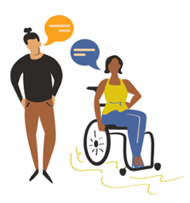What helps and doesn’t help make communities inclusive for people with disabilities and/or chronic illness.

Your ideas to make communities more inclusive?



We will write a report from the information you and others tell us.



We may also make a story with this information.



We will give this to people and put it on the [Planning Inclusive Communities project website](https://www.planninginclusivecommunities.com/).



Your name will not be used in any report, story or paper.



# What will you do in the research project?

Sometimes it is easier to tell a story about what inclusive communities looks like and means to you.

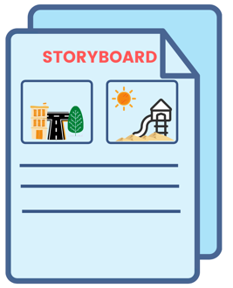

To help you tell your story we have created a storyboard project with some questions for you to complete.

When using the Storyboard book you can tell your answers by:



**Writing**

**Drawing**



**Using photos to make a collage**

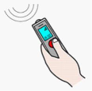

**Record your answers**



If there is a better way for you to tell us your story – please let us know.

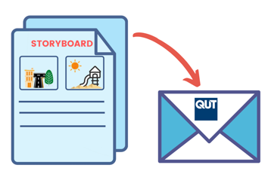Once you have completed your storyboard project you will need to return it to the research team.

# How to return the Storyboard?

# 

If you have completed the storyboard **online**, press the submit button when complete.



If you have downloaded the storyboard in **word document,** you can:



Save your responses and email it to us - inclusivecommunities@qut.edu.au



If you wrote your answers on a printed copy,

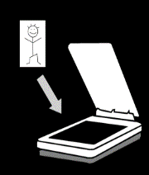

You can scan your storyboard and email us the scanned copy – inclusivecommunities@qut.edu.au

Or

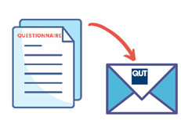You can post your handwritten copy to us.

Dr Lisa Stafford,

School of Public Health and Social Work  
 Queensland University of Technology  
 GPO Box 2434  
 Brisbane, QLD, 4001.

If posting, we can send you a **prepaid envelope**.

Please email us at inclusivecommunities@qut.edu.au or phone us on 07 3138 4595 to request this.



Please take a photo or save a copy of you storyboard before sending it. Once you send it, we can’t return it.



If you ticked yes to being contacted about your answers,



We will make a time to talk to you by phone, video call or face-to-face. We call this a research interview.

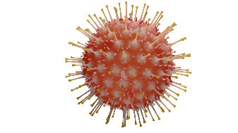

Please note, that during COVID-19 restrictions we will not be able to offer face-to-face interviews.

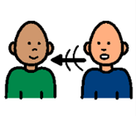We will ask you about your storyboard answers.

This interview may occur 1 to 2 months later.



With your say, we will record what you tell us on a digital recorder. If we use video call like zoom - only audio recording will be undertaken.

# Important information before you start.

# 

Your private information stays private.

# 

We will keep information about you safe.

We may use the responses again in the future.



You can ask someone to help you answer these questions.



You can stop the storyboard at any time.

If you are unsure about any of this information, please stop, and ask someone you know well to help.

You can contact the researcher, Dr **Lisa** Stafford.



Email: lisa.stafford@qut.edu.au

Or

Phone: 07 3138 4595

# What will you get from participating?



You will get information about what we have found about making communities inclusive.

Participation in this research project **will not** directly benefit you.

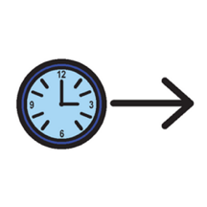

But may help in the future by telling ideas to make communities more inclusive in regional areas.

# Are there risks to me?



You may feel upset telling us about some things, like what makes it difficult.



You do not have to tell us about these things if you don’t want to.

You choose what to tell us and which questions to answer.

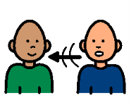

If you get really upset from participating in the research and want to talk to someone like a counsellor you can call:

**Lifeline** on **13 11 14** for 24- hour telephone crisis support

Or

The **Kids Helpline if you are aged 5 to 25** on **1800 551 800**

If you have any questions, please contact:

Dr **Lisa** Stafford

School of Public Health and Social Work

Queensland University of Technology

Email: lisa.stafford@qut.edu.au

Or

Phone: 07 3138 4595



If you are **not happy** with the way the research happened, you can make a complaint to the QUT Research Ethics Advisory Team.



You can phone: 07 3138 5123

Or

Send an email to: humanethics@qut.edu.au

**Images:** We used images from:

* Mayer-Johnson
* Pictoselector
* Pixabay CC
* Canva
* Pexels

This information is for the project: Inclusive Community Planning for people with disabilities in regional areas, ARC DECRA project (project number DE190101512).