# Participant Information for the Survey

Easy English Version 2020



**Information for a research activity on Planning Inclusive Communities research.**

**About Planning Inclusive Communities Research Project**

The research is by Queensland University of Technology. Also called **QUT**.

The **researcher** is Dr **Lisa** Stafford.

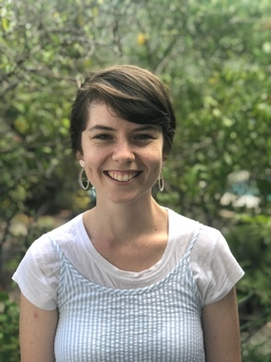

The **research** assistant is **Rosie**.

A **researcher** learns information to help make things better for people.

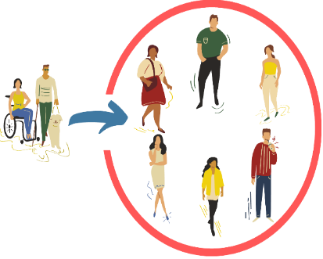

The **research** wants to help make communities inclusive for people with disabilities.

**Community** is the streets around where you live.

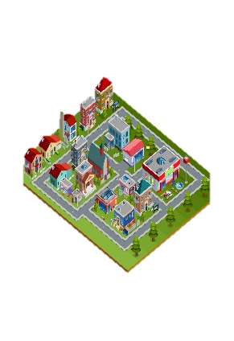

Like you live in Clarence City Council near Rosny Park.

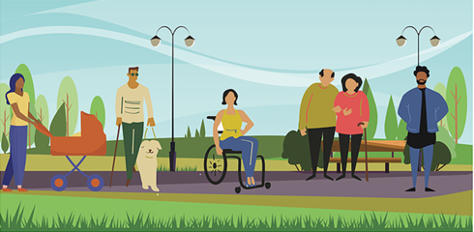

**Inclusive** is having the same choice to do things in your community like everyone else. Like

* Play sports
* Go to shops
* Go to library
* Use the local bus.

**QUT** is working with 2 local councils

Clarence City Council in Tasmania

****and

Gympie Regional Council in Queensland**.**



A group of people at **QUT** check research so it is fair and helpful.

They are called **QUT** **human research ethics committee**.



They checked and said our research is okay.

The QUT Research Ethics Approval Number is 1900000898

**This activity is a Survey.**

A survey asks a lot of different people the same questions.

It helps plan for the future.



**?**

We want to know …

What makes an inclusive community to you?

What helps and doesn’t help make communities inclusive for people with disabilities.



Your ideas to make communities more inclusive?



We will write a report from the information you and others tell us.



We may also make a story with this information.

We will give this to people and put it on the - [Planning Inclusive Communities Website.](https://www.planninginclusivecommunities.com/)



You do not include your name on this form. We call this **anonymous.**

# Who can complete the Survey?

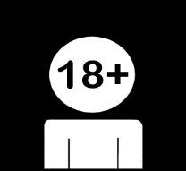Any community member.

Who is 18 years and over.

You **must** live, work or study in:

Clarence City Council Tasmania

Or



Gympie Regional Council Queensland.

# How to complete the questionnaire?



You can complete the questionnaire **Online** on a computer, tablet or phone

Or

Download the word document from the [Planning Inclusive Communities Questionnaire webpage.](http://www.planninginclusivecommunities.com/questionnaire)





Save and then complete.



Remember to save your answers often.



If you don’t have a computer, we can send you the questionnaire in the mail.

Contact the Project team via phone 07 31384595 or email [inclusivecommunities@qut.edu.au](mailto:inclusivecommunities@qut.edu.au)

# What will you do in the research project?

You will be asked to complete **9** questions.



This may take about **15 minutes.**

You will be asked to type or write your answers to each question.





Some questions let you add images or to tell your answers.

Your images can be drawings/designs, paintings, photographs or collages.

If you use the word document in Office 365:



You can use ‘Read Aloud’ option to read the questions

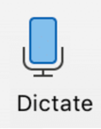

You can use the ‘Dictate’ option to record your answers.



If you need support to complete the survey.

Call us on 07 3138 4595

or email [inclusivecommunities@qut.edu.au](mailto:inclusivecommunities@qut.edu.au)

We can help you answer it over the phone.



Once you have completed your questionnaire you will need to return it to the research team.

# How to return the Survey?

# 

**Online**, press the submit button when complete.



If you have downloaded the survey in word document**,** you can:



Save your responses and email it to us - [inclusivecommunities@qut.edu.au](mailto:inclusivecommunities@qut.edu.au)



If you wrote your answers on a printed copy,

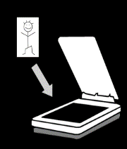

You can scan your survey and email us the scanned copy – [inclusivecommunities@qut.edu.au](mailto:inclusivecommunities@qut.edu.au)

Or

You can post your handwritten copy to us.

Dr **Lisa** Stafford,  
School of Public Health and Social Work  
Queensland University of Technology  
GPO Box 2434  
Brisbane, QLD, 4001

If posting, we can send you a **prepaid envelope**.

Please email us at [inclusivecommunities@qut.edu.au](mailto:inclusivecommunities@qut.edu.au) or phone us on 07 31384595.

# 

# Important information before you start.

# 

Your private information stays private.

# 

We will keep information about you safe.

We may use the responses again in the future.

You can ask someone to help with the questions.



You can stop the survey at any time.



If you are unsure about any of this information, please stop, and ask someone you know well to help.

Or

You can contact **Lisa** the researcher.



Email: [lisa.stafford@qut.edu.au](mailto:lisa.stafford@qut.edu.au)

Or



Phone: 07 3138 4595

# What will you get from participating?



You will get information about what we have found about making communities inclusive.

Participation in this research project **will not** directly benefit you.

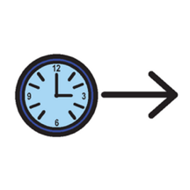

But may help in the future by telling ideas to make communities more inclusive in regional areas.

# Are there risks to me?



You may feel upset telling us about some things, like what makes it difficult.



You do not have to tell us about these things if you don’t want to.

You **choose** what to tell us and which questions to answer.

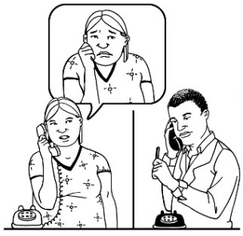

You can talk to a counsellor about things that made you really upset.

Call Lifeline on 13 11 14 for 24 hour telephone crisis support

Or

Call Kids Helpline on 1800 551 800 for people aged 5 to 25 years



Questions, please contact:

Dr **Lisa** Stafford

School of Public Health and Social Work

Queensland University of Technology

Email: [lisa.stafford@qut.edu.au](mailto:lisa.stafford@qut.edu.au)

Or

Phone: 07 3138 4595



If you are **not happy** with the way the research happened, you can make a complaint to the QUT Research Ethics Advisory Team.



You can phone: 07 3138 5123

OR

Send an email to: [humanethics@qut.edu.au](mailto:humanethics@qut.edu.au)

# Before you start



**I have read this information**



Yes. Go to the next question.



No. You can stop now. Please read the information first.



**I understand what is being asked of me?**



Yes. Go to the next question.

No. You can stop now. Please ask someone to help.



**You are 18 years old or older?**



Yes. Go to the next question.



No. You can stop now.



**I understand that sending my completed questionnaire is accepted as my agreement to participate. We call this consent.**

Yes. Go to the next question.



No. You can stop now. Please ask someone to help.



**Did you say yes to all 4 questions?**

No. You can stop now.



Yes. Click here to start the [questionnaire](https://survey.qut.edu.au/f/193845/f6f3/) or scan the QR Code below:



**But**

Remember.

You can stop the questionnaire at any time.



**Images:** We used images from:

* Mayer-Johnson
* Pictoselector
* Pixabay CC
* Canva
* Pexels



This information is for the project: Inclusive Community Planning for people with disabilities in regional areas, ARC DECRA project (project number DE190101512).